New char

Name: myssa daphnia elmyn dorhanna trixis

Race: gnome

Class: pyromancer

Height: 0,8 m

Weight: 18kg

Hair: black

Eyes: almost black

Skin: quite white

Languages: gnomish, common,

16 wis +3

13 str +1

14 dex +2

18 cha +4 save

18 con +4

16 int +3 save

Hp: 12

Ac: 14

Proficiencies

Armor: Light  
Weapons: Simple weapons, shortswords  
Tools: Disguise kit, thieves’ tools

Skills: arcana, deception, persuasion, slight of hand, stealth

Equipment:

2 daggers 1d4 trwn

Explores pack

a shortbow 1d6

an arcane focus, studded leather armor

small knife

map of lake town

pet mouse

token to remember parents

common clothes

10g

<https://www.dandwiki.com/wiki/Pyromancer_(5e_Class)>

(geen one with fire, fiery soul. Scorched earth maar 1 x per rest.)

Background:

Urchin

Feature: City Secrets

You know the secret patterns and flow to cities and can

find passages through the urban sprawl that others would

miss. W hen you are not in combat, you (and companions

you lead) can travel between any two locations in the city

twice as fast as your speed would normally allow.

Personality trait: I think anyone who’s nice to me is hiding evil intent.

Ideal: Change. The low are lifted up, and the high and mighty

are brought down. Change is the nature of things.

(Chaotic)

Bond: owe a debt I can never repay to the person who took pity on me

Flaw: will never fully trust anyone other than myself.

Character I know

Roroum

Broer

Dead

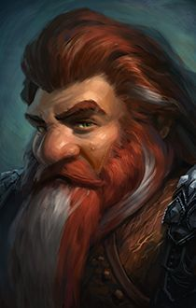

Lún

Schoonzus

